Y9 Programming – Python art project

Design Brief
Design and create a logo using Python turtle or Python pillow module.
The objective of this project is to design and generate the code to draw a logo using the Python programming language. Students will demonstrate their skills and understanding of creating loops, conditional statements, functions and variables to complete the task.

Logo design and generate code assignment.
Select a company or organization to redesign their logo. Alternatively, you can create a logo for a fictitious company.

Step 1: Find 3 logos from the internet that represent companies similar to your company or organization.
Step 2: Complete the Creative Brief Worksheet
Step 3: Design your logo that is represented your company profile or product.
Step 4: Generate code to produce the designed logo using Python turtle or Python pillow module.

Design research: competitors’ logos
Research three competitors logos and complete the table below.
 | Logo 1 | Logo 2 | Logo 3
Logo  (Include a picture) | 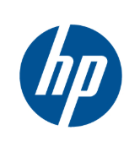 | 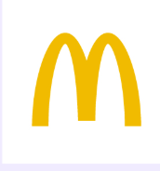 | 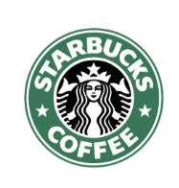
What works well? | The blue colour of the HP logo conveys trust, reliability, and intelligence, which is needed for a tech company. HP has used blue as its primary brand colour for a long time; this makes the colour tied to the brand and be easily recognisable. It also has a slight slant on the h and p, making it look quite unique and demonstrate movement. | The bright yellow Golden Arches grabs the attention of people; it stimulates appetite and display happiness which works well with McDonald’s red which demonstrate energy and urgency. The yellow helps trigger people’s hunger while the red conveys speed. Its minimalistic design ensures its visibility from any size or distance and allows it to be recognised even without the name. | The twin-tailed siren symbolises obsession and the irresistible call for coffee. Additionally, the green colour influences people to believe Starbuck is fresh and has premium quality; this conveys it as a more sustainable, natural, and ethical source coffee option.
What could be improved? | The logo is white and blue which limits the flexibility on different applications such as on dark modes. Perhaps having an inverted option or different colour variants can be used, that way the logo can be more practical. | The logo is minimalistic and simplistic, which in some circumstances may not fit or look good. There could be a slight change in the logo that can be used for different purposes, such as making it look slightly 3D. | The siren’s features may come off as a creepy in which a softer style could enhance it. The tail and hair also are quite complex which can lose detail in small areas. An alternative simplistic logo can be introduced in such circumstances.

Creative brief worksheet
In order to create a successful design that meets your clients’ needs, you must first take the time to get to know your client and what their needs are. Below is a client brief that a design company uses when beginning a job for a client. Complete this worksheet for your client. (Note: Although you are not the client, imagine that you are and complete the Creative brief worksheet.)

Project Summary

✴What type of product or service do you offer?
✴What do you hope to accomplish with your new business?
It’s a technology-based café that offers coffee, milkshakes, and quick snacks/treats only ordered through a mobile app. The in real life store is solely for creating these food items and pick up to minimize cost and space. The aim is to make food and drink ordering and pickup convenient, efficient, and uncostly through technology.

Audience Profile
Who is your target audience and what they care about.
✴Please describe your existing audience.
My audience is students, workers, and people who want a quick meal or coffee without having to wait long. It is for people who want to browse and order everything they want online to not waste time at the store.

Perception / Tone / Guidelines
How do you want your target audience to respond to your new logo
✴Do you have any colours in mind for your logo? (if so, why?)
✴Do you have any specific images or icons in mind that you would definitely like to see incorporated into your logo?
I want my target audience to feel that the logo is modern, friendly, and reliable. Since my business is technology and food related, the logo should make my customers think the brand is fast, convenient, and trust-worthy.

I can use a mix of red, yellow, blue, and green. The red and yellow works quite well for food companies as it stimulates appetite, energy and happiness. The blue adds trust to my brand and if I want my business to look a bit healthier/fresher, I can incorporate green as well.

The logo should stand out and be easy to remember. I can do this by keep it simple, bold, and clean so it can work well on the app, cup, or packaging. The logo should convey speed and convenience but not too corporate. Perhaps having circular/rounded shape will make it feel more approachable and friendly. A simple icon such as a coffee cup, snack, or wi-fi symbol to display my company as both food and technology based.

Communication Strategy

How you intend to reach your targeted audience and what the overall message is
✴Do you have a tagline or slogan?
✴What is the overall message you are trying to convey to your target audience?
My communication strategy is to reach to students and bus customers with a clear message that my store offers quick, delicious, and convenient food and drinks through modern technology. The brand is to feel friendly, not complicated or overly formal. A possible slogan could be Order, Grab, Go.

Competitive Positioning
What is it that makes you stand out from your competition?

✴What sets you apart from your competitors or other businesses?
What sets my company apart is that it allows customers to order through an app and do a quick pickup, making my business more convenient than a normal café. So, there is faster service and a smoother customer experience. Unlike other businesses, my brand feels more modern and organized compared, making it stand out from traditional café and fast-food stores.

Targeted Message

✴ State a single-minded word or phrase that will appropriately describe your company.
Quick and convenient.

Design draft logo
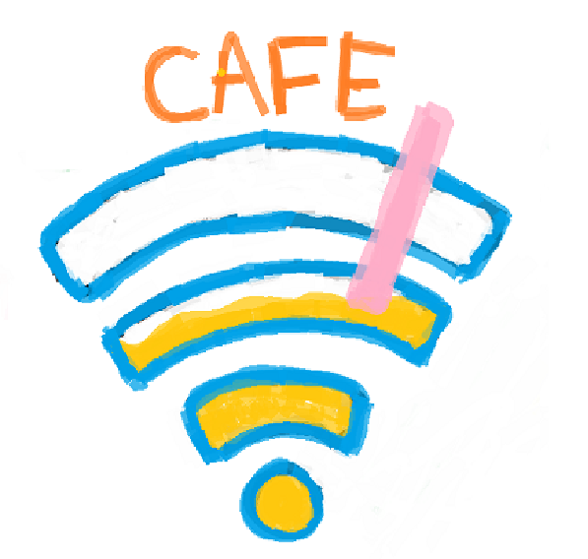

Program output and code

Description | Screenshot
Screenshot of your logo. | 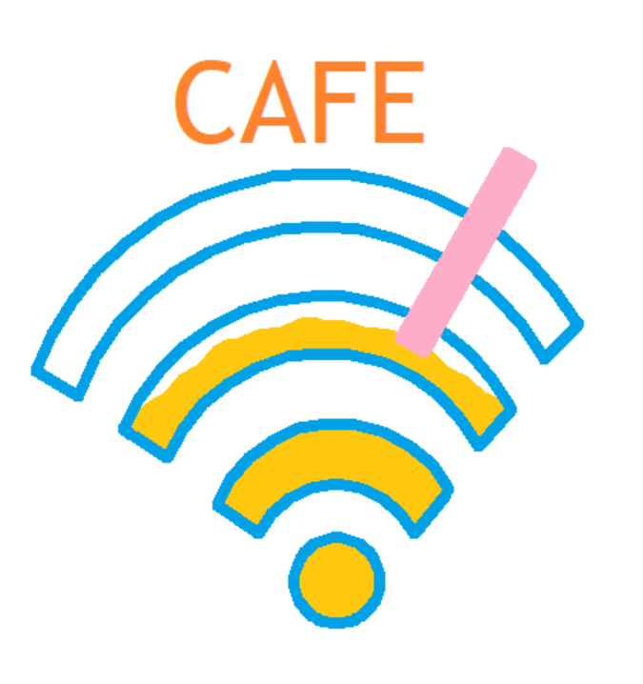
Code generating the logo. Copy/paste your code here. | from turtle import *  import turtleBeads  pendown()  hideturtle()  # draw bottom circle of the wifi part  turtleBeads.teleport(0, -175)  pensize(8)  pencolor("#00a1e7")  begin_fill()  turtleBeads.drawCircle(30)  fillcolor("#ffc80e")  end_fill()  # Draw arc  def draw_arc(radius, heading):  setheading(heading)  circle(radius, 130)  # The lines  def lines(head):  setheading(head)  forward(35)  # first one  turtleBeads.teleport(76, -115)  begin_fill()  lines(230)  draw_arc(60, 115)  lines(146)  draw_arc(-90, -291)  fillcolor("#ffc80e")  end_fill()  # second one  turtleBeads.teleport(122, -55)  begin_fill()  lines(228)  draw_arc(120, 117)  lines(148)  #liquid  pencolor("#ffc80e")  fillcolor("#ffc80e")  def liquid(num, direction):  setheading(direction)  for i in range(num):  circle(30, 30)  circle(-30, 30)  print(pos())  liquid(3, 25)  liquid(2, 0)  liquid(2, 335)  liquid(3, 310)  print(pos())  end_fill()  turtleBeads.teleport(122, -55)  pencolor("#00a1e7")  draw_arc(150, 118)  # third one  turtleBeads.teleport(145, -20)  draw_arc(180, 119)  turtleBeads.teleport(168, 5)  draw_arc(210, 120)  lines(330)  turtleBeads.teleport(145, -20)  lines(46)  #drawing straw  turtleBeads.teleport(44.07,-4.87)  setheading(60)  begin_fill()  fillcolor("#fdadc8")  pencolor("#fdadc8")  def straw(up):  forward(up)  right(90)  straw(150)  straw(20)  straw(150)  straw(20)  end_fill()  # word  turtleBeads.teleport(-115, 110)  pencolor("#fe832f")  write("CAFE", font = ("Trebuchet MS", 60))  turtleBeads.teleport(-148.48,-70.05)  pencolor("#00a1e7")  pensize(3)  forward(10)  backward(10)  left(90)  pensize(8)  backward(5)  turtleBeads.teleport(120.39,-58.31)  left(75)  forward(10)  mainloop()

